EXPERIMENT – 3.

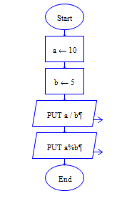

Output

